**🔹 Different Authentication Techniques in API Development**

Apart from **JWT (JSON Web Token)**, APIs commonly use different authentication methods based on security, scalability, and use cases.

**1️⃣ Authentication Methods Comparison Table**

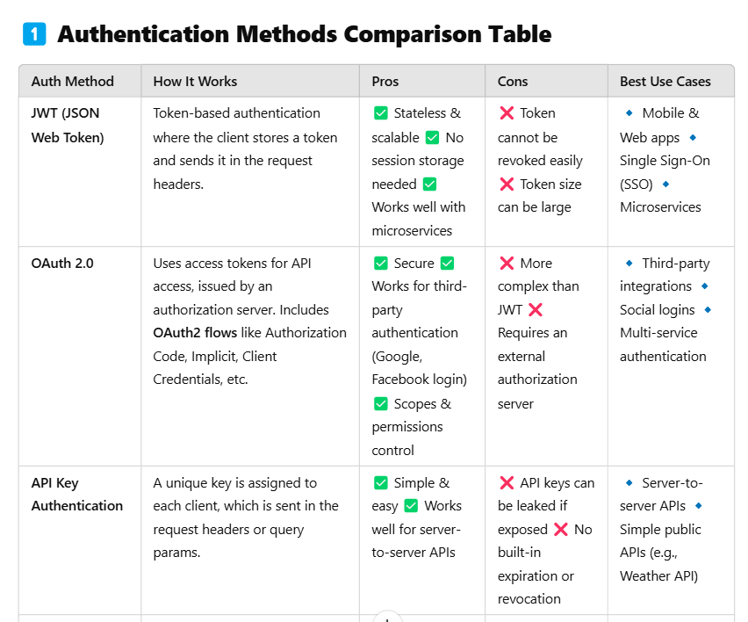

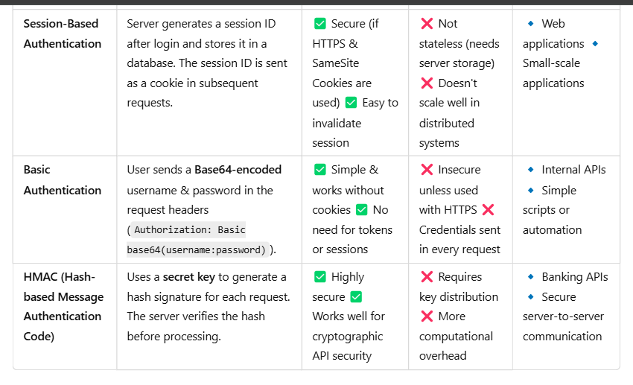

**2️⃣ When to Use Each Authentication Method?**

| **Scenario** | **Best Authentication Method** | **Why?** |
| --- | --- | --- |
| **Public API (No User Accounts)** | API Key Authentication | Simple & works without user logins |
| **Secure Web or Mobile App Authentication** | JWT Authentication | Stateless, scalable, and supports mobile |
| **Login with Google, Facebook, etc.** | OAuth2.0 | Supports third-party authentication |
| **Enterprise Authentication (SSO, Microsoft 365, AWS, etc.)** | OAuth2.0 with OpenID Connect | Supports SSO & enterprise security |
| **Internal API for Automated Services** | HMAC Authentication | Ensures request integrity with a secret key |
| **Small Web App with Session Management** | Session-Based Authentication | Allows session invalidation and CSRF protection |
| **CLI Tool or Script Authentication** | Basic Authentication | Simple, but must use HTTPS |

**3️⃣ Pros & Cons of JWT vs OAuth2 vs API Keys**

| **Feature** | **JWT** | **OAuth2** | **API Key** |
| --- | --- | --- | --- |
| **Stateless?** | ✅ Yes | ✅ Yes | ✅ Yes |
| **Secure?** | ⚠️ Medium (Token exposure risk) | ✅ High (OAuth Server controls access) | ❌ Low (Easy to leak keys) |
| **Supports User Authentication?** | ✅ Yes | ✅ Yes | ❌ No (Only identifies client apps) |
| **Easy to Implement?** | ✅ Yes | ❌ No (More complex) | ✅ Very Easy |
| **Can be Revoked?** | ❌ No (Needs token blacklist) | ✅ Yes | ❌ No |
| **Best for Public APIs?** | ❌ No | ❌ No | ✅ Yes |

**🔹 Conclusion: Which Auth Method Should You Use?**

| **Scenario** | **Best Authentication Method** |
| --- | --- |
| **Microservices / Stateless Apps** | JWT |
| **SSO (Google, Facebook, etc.)** | OAuth2 |
| **Simple API Access** | API Keys |
| **Internal API Calls (Server-to-Server)** | HMAC |
| **Web Applications (CSRF Protection Needed)** | Session-Based Authentication |
| **Automated Scripts & CLI Tools** | Basic Authentication |